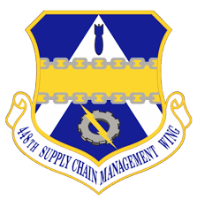

SASPO – Tinker Industry Day Agenda

Location: Reed Conference Center

5800 Will Rogers Rd.

Midwest City, OK 73110

Date: August 8th, 2024

Time: 1300-1600 hrs. CDT

Agenda Items

1300-1305 Opening Remarks Mr. Jerry Zamora

1305-1320 Small Business Ms. Stacy Cochran

1320-1420 SASPO Programs – Panel Discussion Mr. Randy Harris

Reverse Engineering/Repair Development (RERD) Mr. Brian Butler

Other Transaction Authority (OTA) Ms. Danielle Knox

Source Approval Request (SAR) Mr. Rick Johnson

1420-1435 Weapon Systems Opportunities Mr. Brian Butler

1435-1500 Networking Break

1500-1530 SAR Training Mr. Jonathan Mason

1530-1535 Closing remarks Mr. Jerry Zamora